NAME: IBEKWE BRIAN OGOCHUKWU
MATRIC NUMBER: 17/SCI01/037
COURSE CODE: CSC312
Question
With the aid of a diagram, describe how a C++ code can be converter to Machine Language code.
Solution
The Programming Process
Computers do not understand human languages. In fact, at the lowest level, computers only understand sequences of numbers that represent operational codes (op codes for short). On the other hand, it would be very difficult for humans to write programs in terms of op codes. Therefore, programming languages were invented to make it easier for humans to write computer programs.
Programming languages are for humans to read and understand. The program (source code) must be translated into machine language so that the computer can execute the program (as the computer only understands machine language). The way that this translation occurs depends on whether the programming language is a compiled language or an interpreted language.
Compiled languages (e.g. C, C++)
The following illustrates the programming process for a compiled programming language.
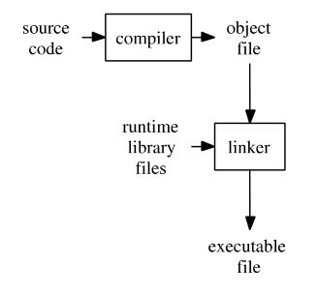
A compiler takes the program code (source code) and converts the source code to a machine language module (called an object file). Another specialized program, called a linker, combines this object file with other previously compiled object files (in particular run-time modules) to create an executable file. This process is diagrammed below. Click Initial build to see an animation of how the executable is created. Click Run executable to simulate the running of an already created executable file. Click Rebuild to simulate rebuilding of the executable file.

